After the Attack

The May 1999 NATO-attack on the Chinese embassy in Belgrade, Serbia, has caused an unexpectedly fierce popular reaction against perceived Western hegemonism. In the 1960s and early 1970s, Chinese military strategists were seriously considering the possibility that China would be attacked by either the United States or the Soviet Union. To prepare for this eventuality, various policies were adopted, including that of the "Third Front" (sanxian). Under this latter policy, a number of industrial plants considered essential for the national defense effort were moved to the interior.
To prepare the people and the army for the eventuality of warfare, a number of educational series were produced in the early 1970s. The "Posters showing measures against atomic, chemical and bacteriological warfare"-series, published in 1971 by the General Department of the Chinese People's Liberation Army, is an example. It is presented here in full, including a so-called head and tail, and the stirring preamble written by Mao Zedong as it was required in those days. A number of posters is moreover accompanied by relevant Mao-quotes (in red).
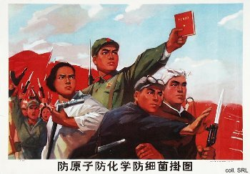 | 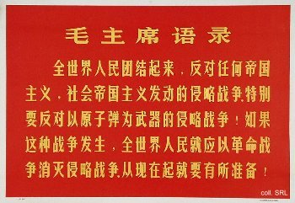

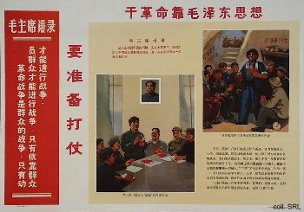 | 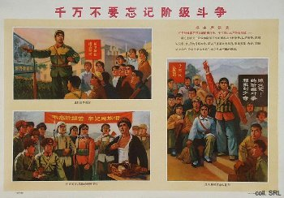
Most important is the ideological preparation for war.
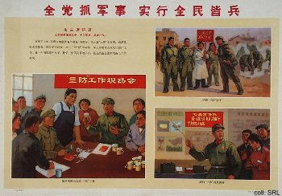 | 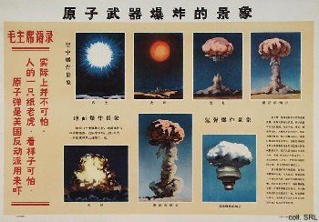
Then, the types of nuclear devices used in attack have to be identified.
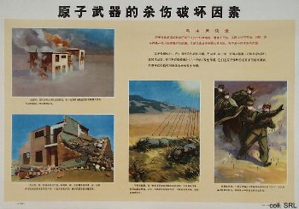 | 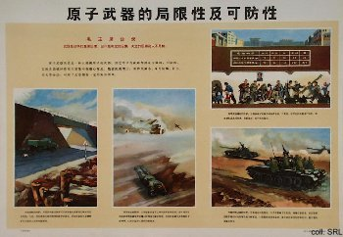
The destruction that nuclear devices cause.
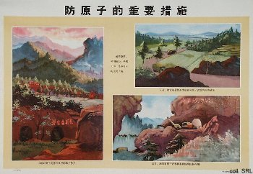 | 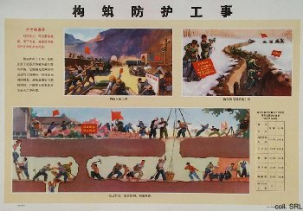
Locating natural shelters and constructing artificial ones.
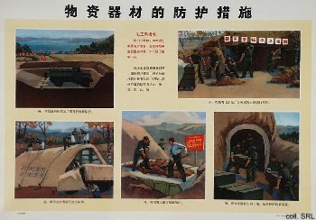 | 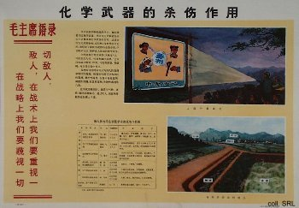
Constructing shelters, and identifying lethal types of chemical warfare.
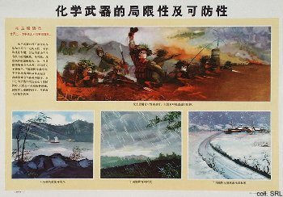 | 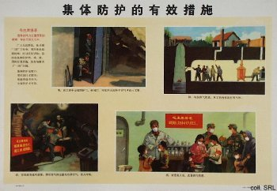
The effects of chemical weapons, and taking effective collective precautions against them.
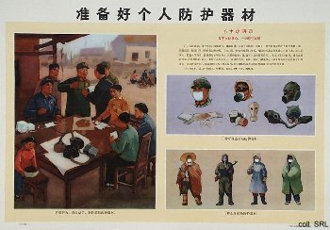 | 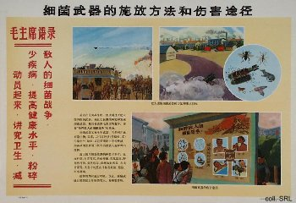
Protection against chemical warfare, and the use of bacteriological weapons.
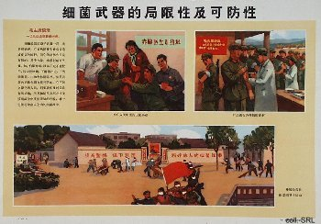 | 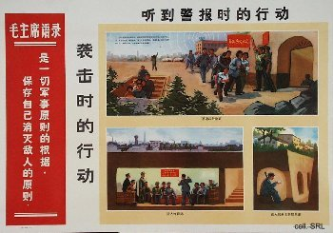
Protection against bacteriological warfare, and what to do when the air-raid warning sounds.
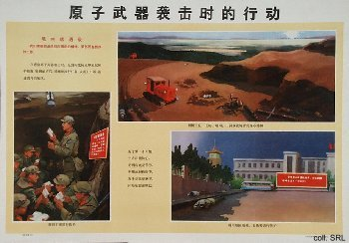 | 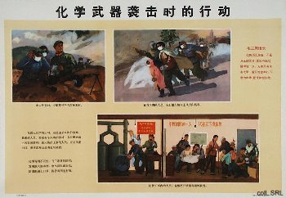
What to do after an attack with nuclear or chemical weapons.
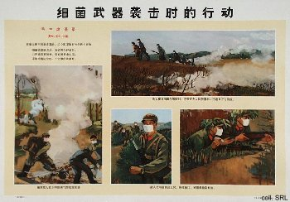 | 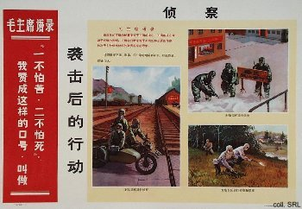
What to do after an attack with bacteriological weapons, and maintaining order after an attack.
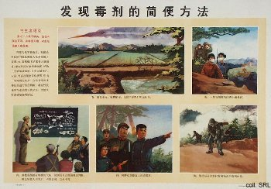 | 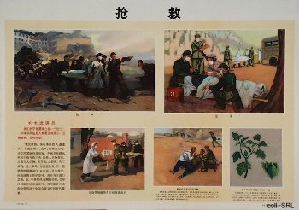
Identifying contamination and poisoning.
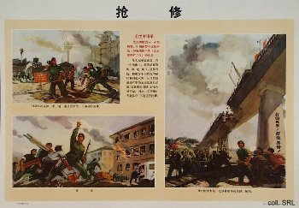 | 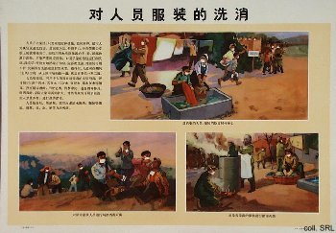
Clearing away rubble and structures that may cause danger; decontaminating people.
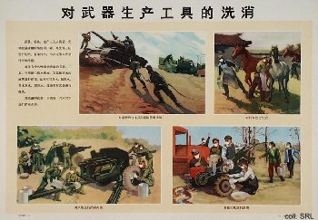 | 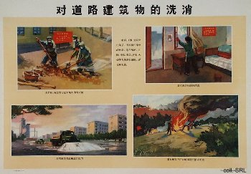
Decontanimating materiel, trucks, cattle, roads and houses.
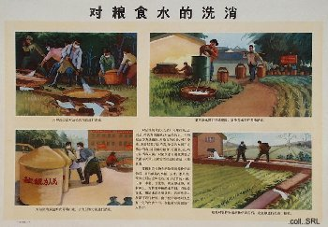 | 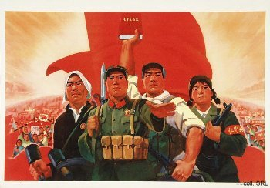
Decontanimating foodstuffs and water.

