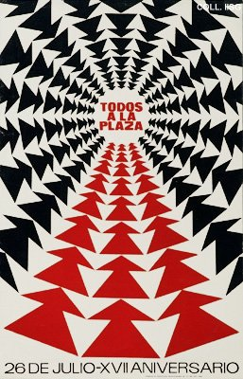 |  | A. Prieto, 1970  All to the square. July 26 - 17th Anniversary  Publisher: Comisión de Orientación Revolucionaria  (Silkscreen, 104x67 cm., inv.nr. BG E3/824)  July 26 is the anniversary of Fidel Castro's attack on the Moncada Barracks in 1953. This is his first attempt at a coup. The attack fails completely. Castro and his small group of rebels are arrested. The attack is seen as the starting point of the Cuban revolution, and is celebrated every year with a big meeting at the Square of the Revolution in Havana.  See also nr. 10

