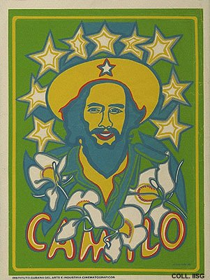 |  | Raul Martínez, 1969  Camilo  Publisher: ICAIC  (Silkscreen, 82x62.5 cm., inv.nr. BG E3/899, coll. Martinez)  Camilo Cienfuegos, one of the captains in Castro's rebel army, is the most popular figure from the days of the guerrilla, together with Fidel Castro and Che Guevara. He is known for his courage, verging on recklessness. He dies in an airplane crash in October 1959.

