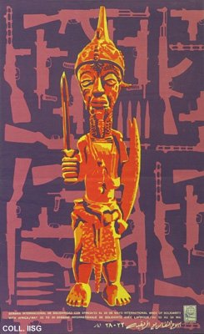 |  | Designer unknown, ca. 1969  International week of solidarity with Africa  Publisher: OSPAAAL  (OSPAAAL, 53.5x33 cm., inv.nr. BG D12/857)  Poster issued by OSPAAAL, the organization for solidarity with the peoples of Africa, Asia and Latin America. For OSPAAAL, solidarity comes down to supporting armed struggle. The most frequently used motif on their posters is the gun. Often, as in this poster, modern arms are combined with traditional weapons, to suggest the national authenticity and historical continuity of resistance

